* **Practical 3**

**Aim:** Forensics Case Study: Solve the Case study (image file) provide in lab using Encase Investigator or Autopsy **Steps: Autopsy:**

Step 1: Start Autopsy from Desktop.



Step 2: Now create on New Case.

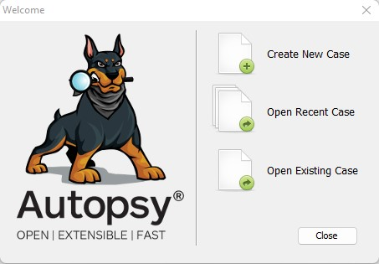

Step 3: Enter the New case Information and click on Next Button.

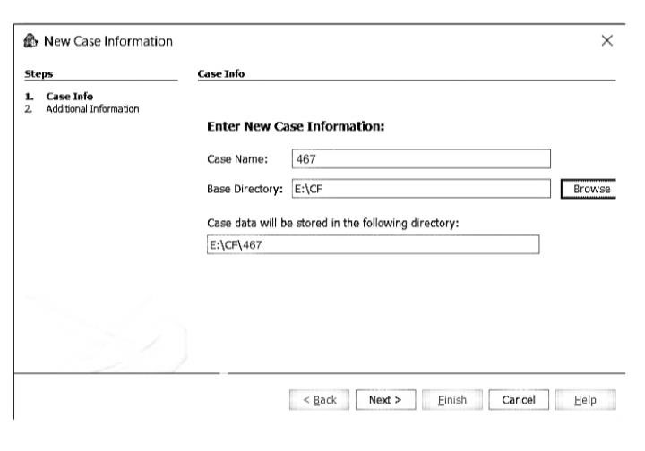

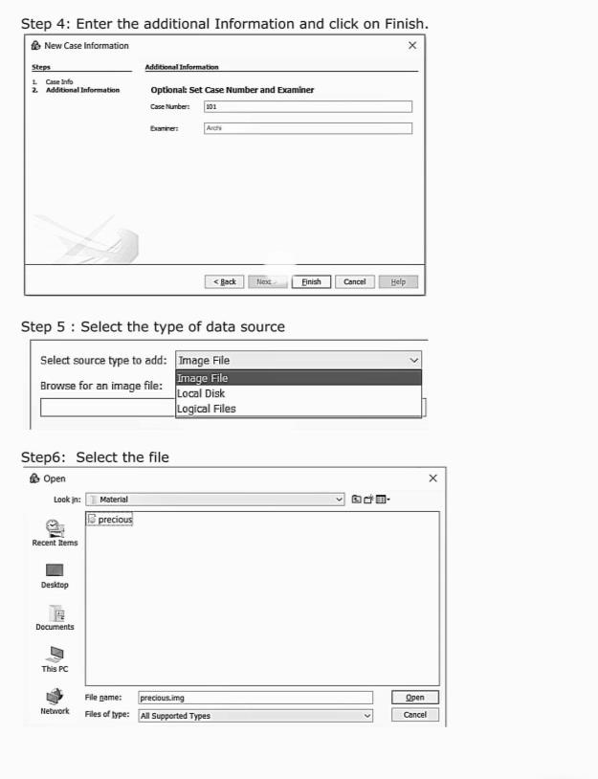

Step 7: Now Select File as Precious.img and click on Next.

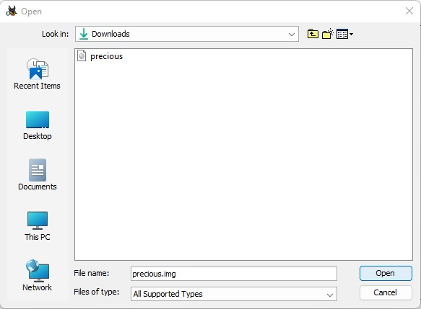

Step 8: Click on Next Button.

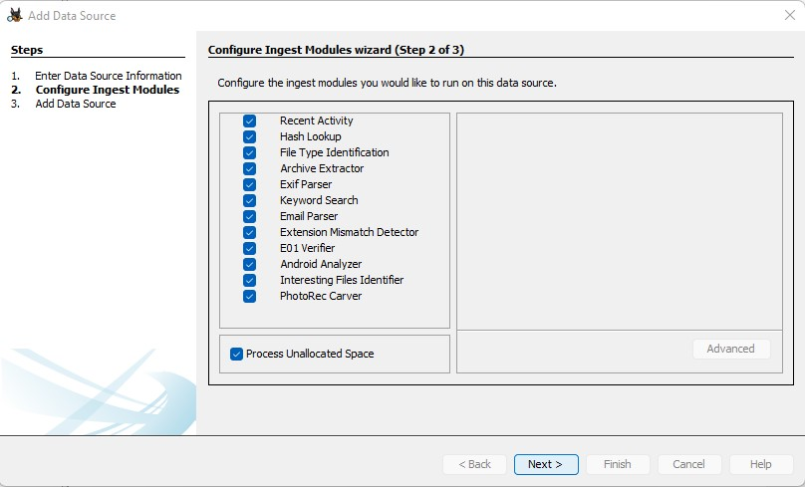

Step 7: Now click On Finish.

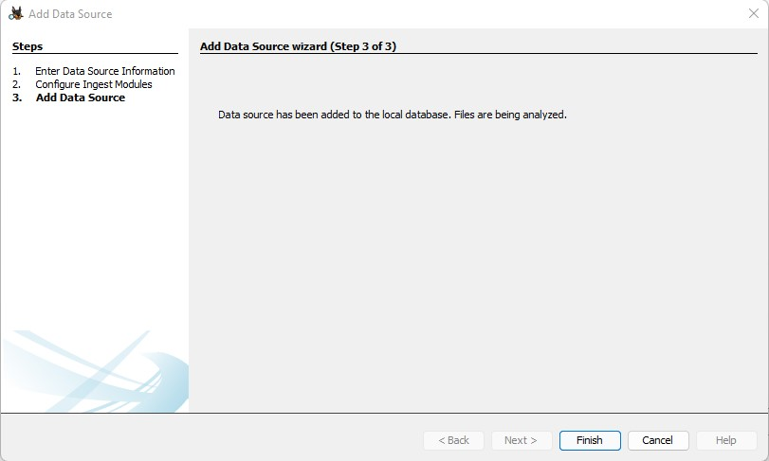

Step 8: Now Autopsy window will appear and it will analyzing the disk that we have selected.

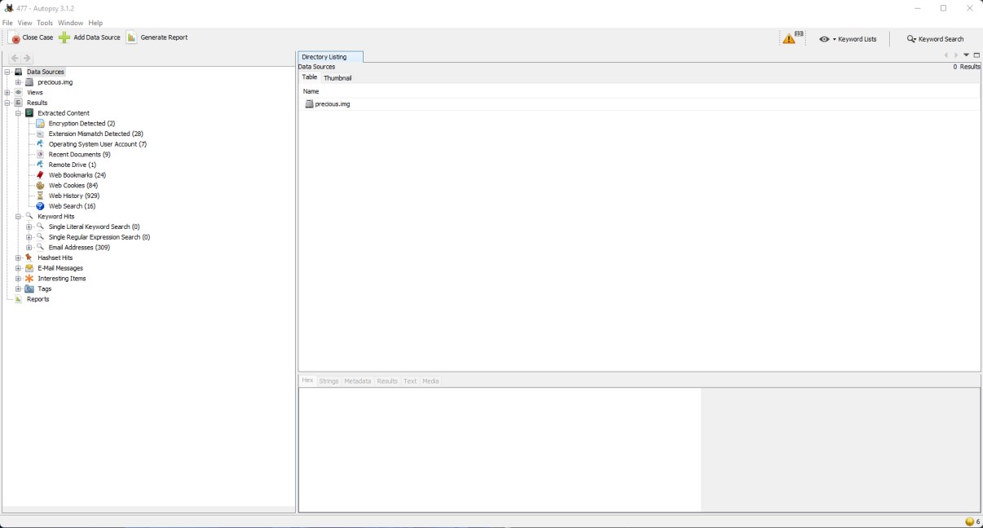

1. Search by file extension

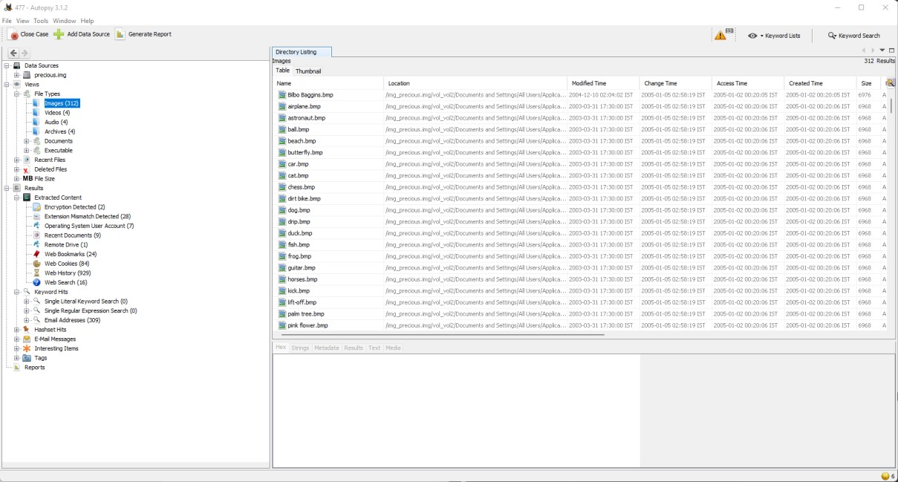

1. Search by MIME type

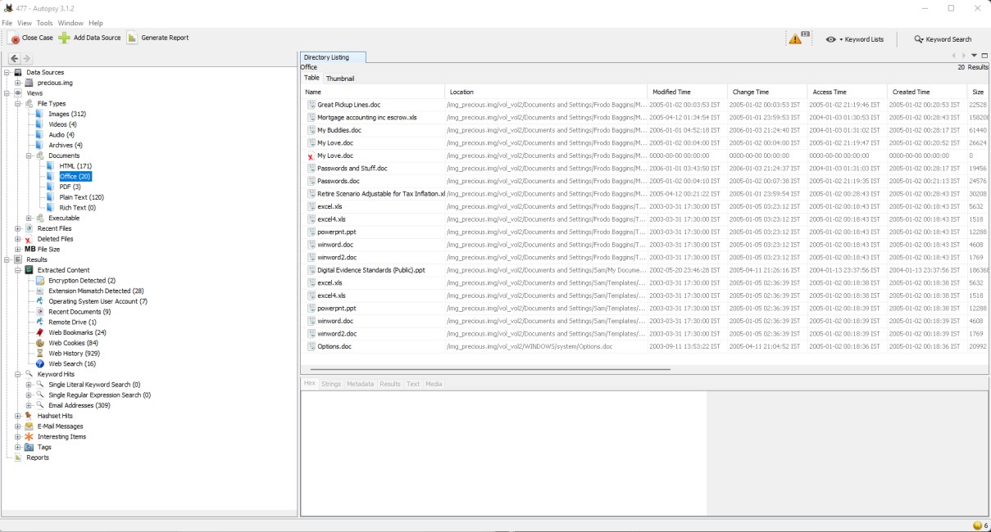

Step 9: By default, Export folder is chosen to save the recovered file.

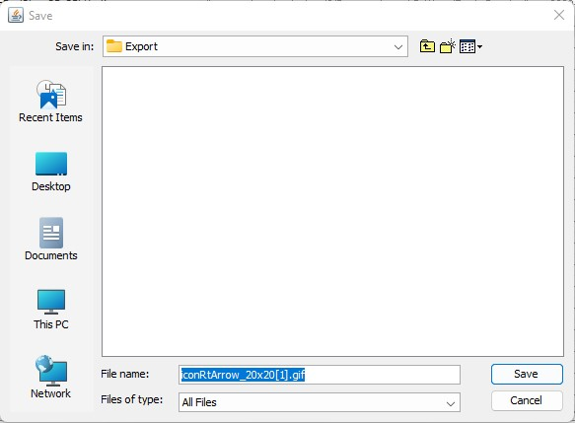

Step 10: Expand the tree from left side panel to view the document files.

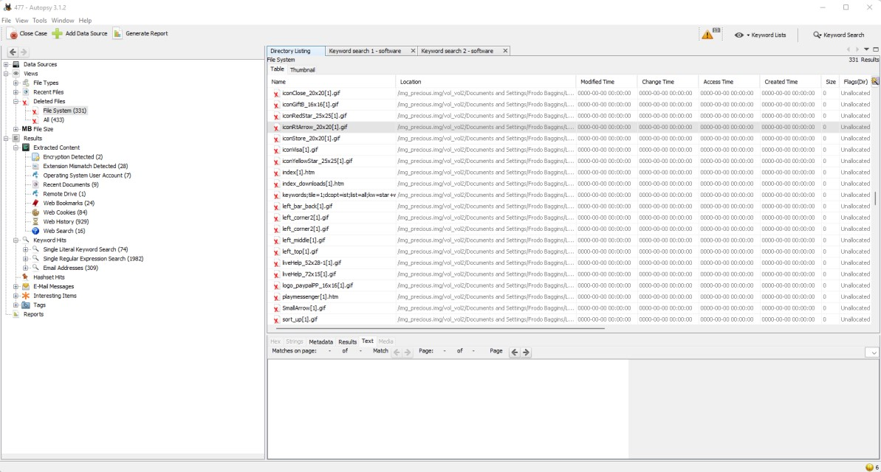

Step 11: To recover the file, go to view node-> Deleted Files node, here select any file and right click on it than select Extract Files option.

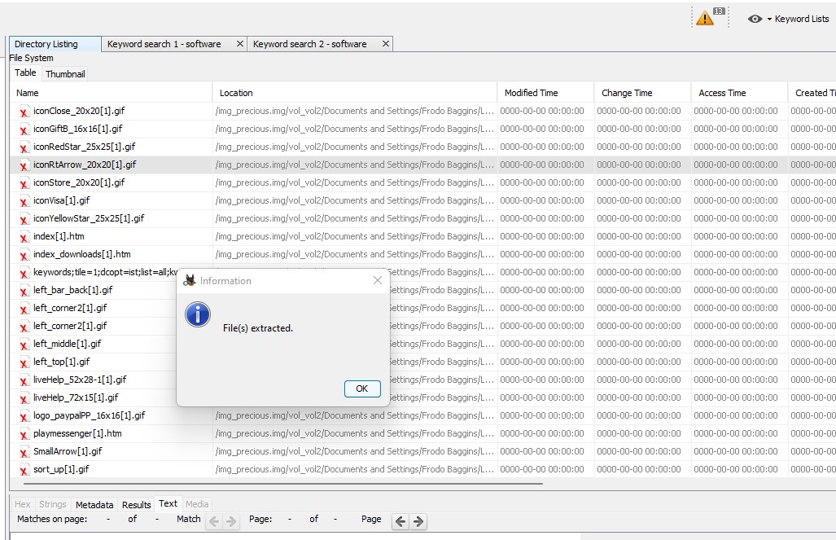

Step 12: Now go to the Export Folder to view Recover file.

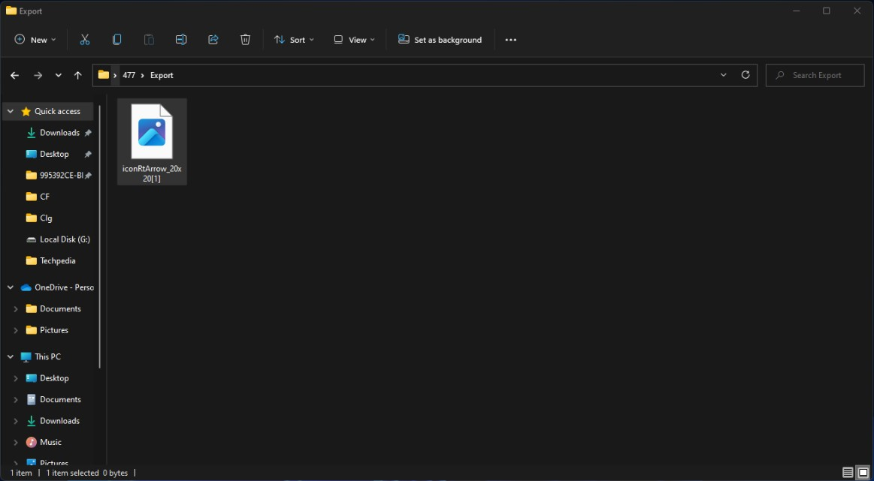

Step 13: Click on Generate Report from autopsy window and Select the Html format and click on next.

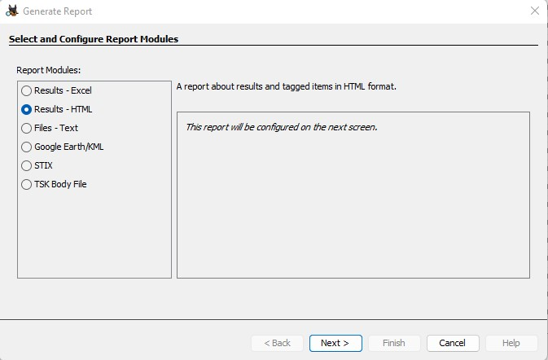

Step 14: Now Report is Generated So click on close Button. We can see the Report on Report Node.

.

